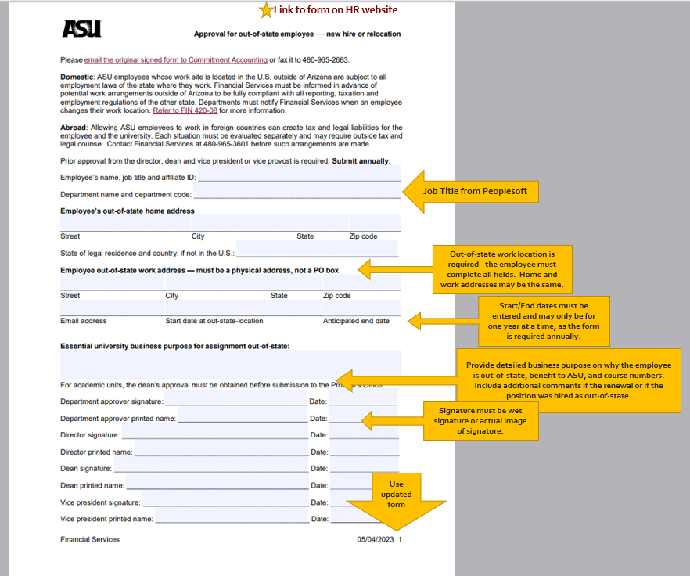

Required field

**Email completed OSE forms to Carrie Montana (**[**cmontan7@asu.edu**](mailto:cmontan7@asu.edu)**) to request routing for Dean/Provost approval. After the provost reviews and approves, the form will be forwarded to Commitment Accounting. Once it's fully approved, the Dean's office will return the form to the unit.**