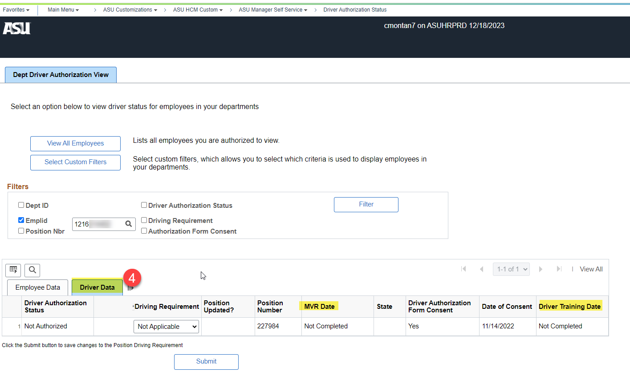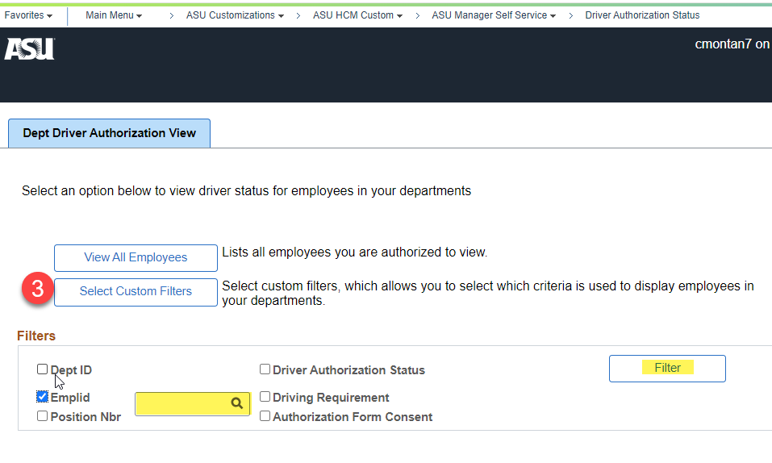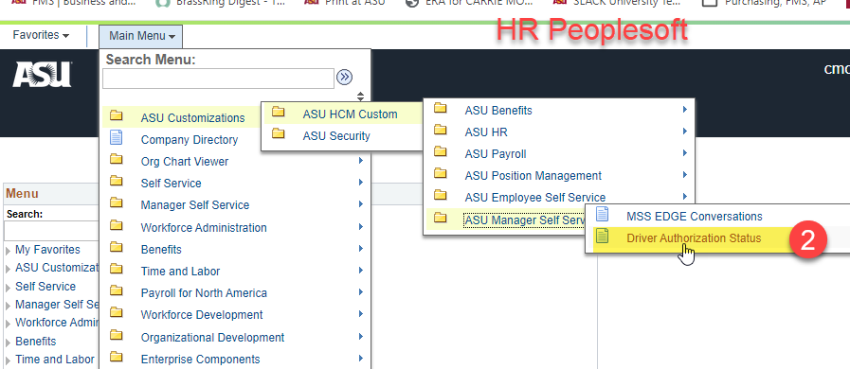 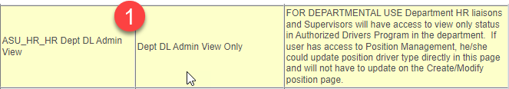

Then click the **Driver Data tab.** This will show you the status and allow you to update the driving requirement. It should be

optional for faculty/staff traveling on ASU business. Once updated, click the submit button to save any changes.

**NOTE:** If the employee/volunteer is outside of your dept, you will need to ask that employee/volunteer’s Department HR Specialist for their status. To check the status of a volunteer use the HR Analytics Authorized Driver report.

The **Driver Authorization Status**

**page** allows you to view by

employee ID or department ID,

under select custom filters.

To view information for authorized

driver, navigate to the Driver

Authorization Status page in

Peoplesoft. If you do not have access, request the **Dept DL Adm in View Only** role which will allow managers to see employees in their department.