When ASU funds are used (by Pcard or reimbursement) to have food delivered to campus or you purchase and bring food onto campus, there is a new policy that has to be followed. Based on this new policy, if the restaurant has a priority violation on a routine inspection, then we are unable to order from that restaurant or process the reimbursement request.

Here is the quick link: <https://envapp.maricopa.gov/EnvironmentalHealth/FoodInspections/Business?Length=15>.

Additional guidelines and processes can be found at <https://eoss.asu.edu/food-safety-and-health>.

Below are a couple of examples:

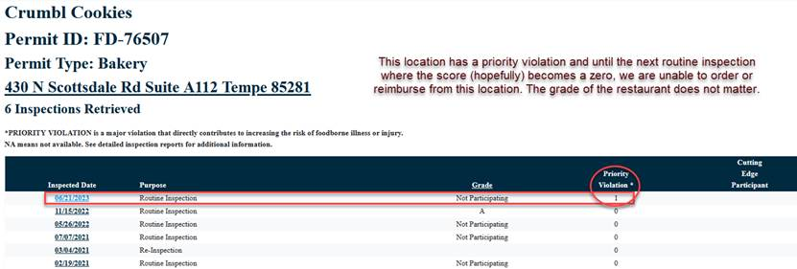

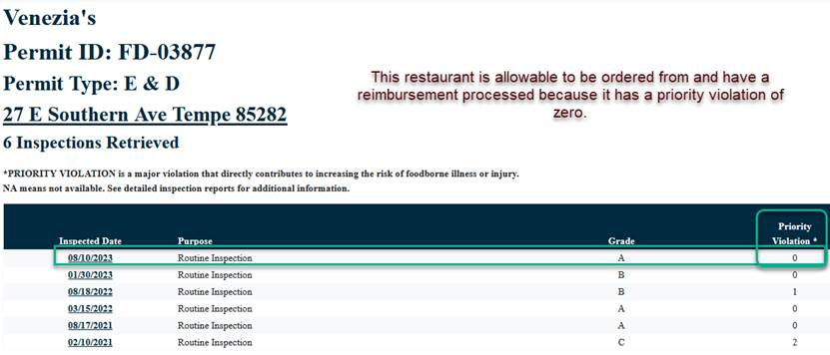

Now, if you are eating at the restaurant location and requesting reimbursement or using a Pcard to pay at the location, that is allowable since no food is entering ASU space. They do advise to check the priority violations prior to dining just in case, but it is an eat-at-your-own-risk policy at that point.

When requesting Pcard payment or reimbursement requests, please attach a PDF of the Maricopa County website with the restaurant you are purchasing the food from. Here is the quick link: <https://envapp.maricopa.gov/EnvironmentalHealth/FoodInspections/Business?Length=15>.

If you are purchasing bulk items using ASU funds (pre-packaged fruit snacks, bottled water etc) from Costco or Wal-Mart for example, the same priority guidelines have to be followed as listed above.